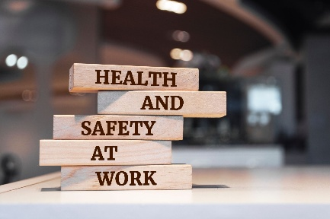
Hello everyone,
As your new Health & Safety Representative, I’m here to support your well-being - at work and beyond. A few times a year, you’ll receive this short newsletter with tips, updates, and space to raise any health and safety concerns. If you have questions, concerns, or suggestions for future topics, please don’t hesitate to reach out. You can contact me by emailing the local at hospicelocal2017@gmail.com. For now, I’ll also be covering La Maison de l’Est until a member steps forward to take on that role. If you’re interested, please let your union representative know. If you work at the Ruddy Shenkman site, please direct all Health & Safety inquiries to hospicelocal2017@gmail.com, where Irene Ritchie remains available to assist.
I look forward to hearing from you and working together to keep our workplaces safe and respectful.
In solidarity,
Your Health & Safety Representative – Chantal Hebert

Number of reported injuries for 2025 at MayCourt

Only one reported injury so far.

Are you in the know?
💉 Comfort Tips for Using 3 cc Saline (NaCl) Flushes

We’ve heard concerns from staff about the pressure when using 3 cc Saline (NaCl) flushes. In response, some have begun using a separate syringe and needle to draw saline from the flush. While we understand the intent, this practice increases the risk of needle stick injuries and should be avoided.

To improve comfort and control:
- Pull back the piston slightly, then push up to expel air before flushing.
- This technique allows for a gentler flow into the subcutaneous line.
- Flush slowly and steadily - a slow approach makes a big difference.

Please note: some clients may still report a pinch, which is often due to the solution itself rather than the pressure.
🔹 Reminder: Use one flush per client only.
🔹 Do not transfer saline between syringes.

Thank you for your continued attention to safe and compassionate care.

⚠️ Product Safety Reminder: Use N9 with Care

Please remember to read product labels carefully or ask before spraying any cleaning agents in shared spaces.
It was recently reported that N9, a chemical cleaner designed specifically for shower room sanitation, was used to control odors. This product is not safe for use as an air freshener zit can cause significant irritation to the eyes and lungs.
To ensure a safe environment for all:
- Use products only for their intended purpose
- Check labels before spraying
- When in doubt, ask your supervisor or Health & Safety Representative

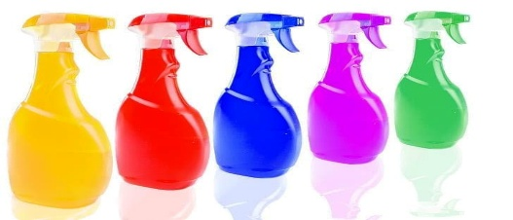
Thank you for helping keep our workplace safe and breathable for everyone.
❄️ Seasonal Health Reminder: Protect Yourself & Others

As the weather cools and we spend more time indoors, respiratory illnesses tend to rise. Let’s stay proactive in keeping ourselves and each other healthy.

Effective prevention includes:
- 💉 Staying up to date with vaccinations
- 🧼 Frequent hand washing
- ↔️ Maintaining distance when possible
- 🏠 Staying home if you have symptoms
Supporting your immune system also makes a difference:
- 🛌 Get adequate sleep
- 🥗 Eat nutritious meals
- 🚶‍♀️ Stay active
- 😄 And don’t forget to laugh - it’s good for your health

Thank you for continuing to care for your colleagues and clients. Let’s keep our workplaces safe and resilient this season.
😂 Did You Know? Laughter Boosts Immunity
An early study by Berk et al. (1989) found that laughter can suppress stress-related hormones like cortisol while enhancing immune markers and natural killer cell activity.
A Dose of Laughter
Q: What did Dracula say to the nurse?

A: “Please call the doctor - I cannot stop coffin”
Happy Halloween!

